**User Story #4 (Firefox)**

**Steps**

1. Land on <https://www.carnival.com>

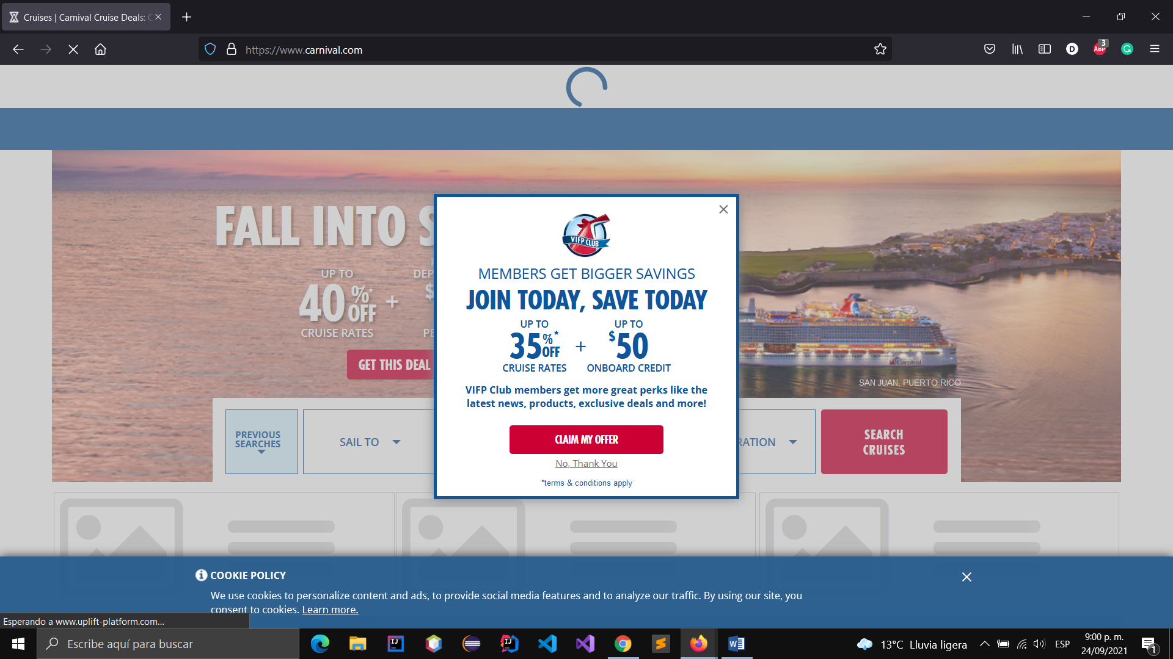

1. Verify land on Carnival
2. Close offer modal

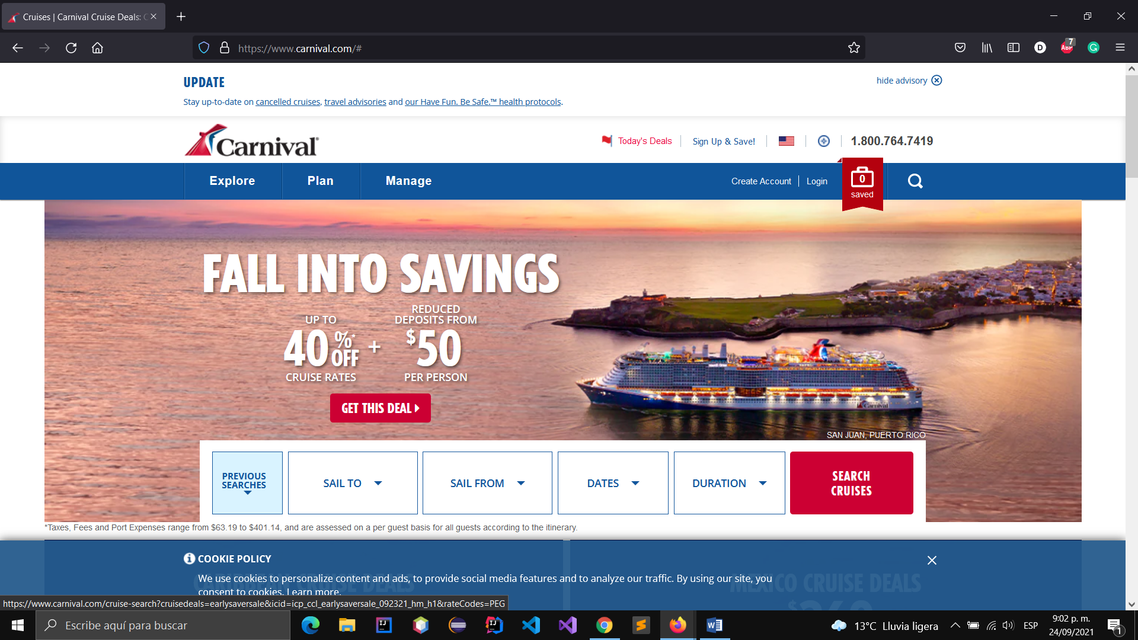

1. Close cookie banner

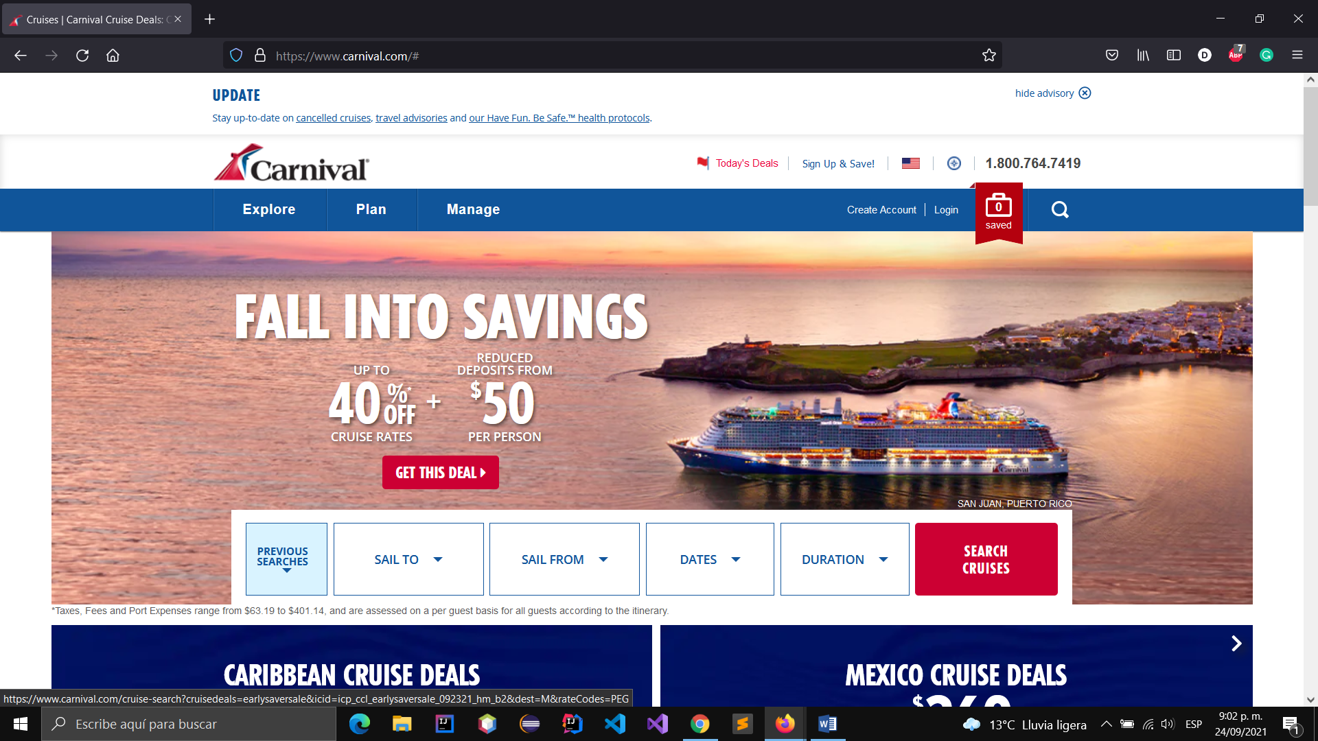

1. Verify that the link is displayed in the footer of the page.

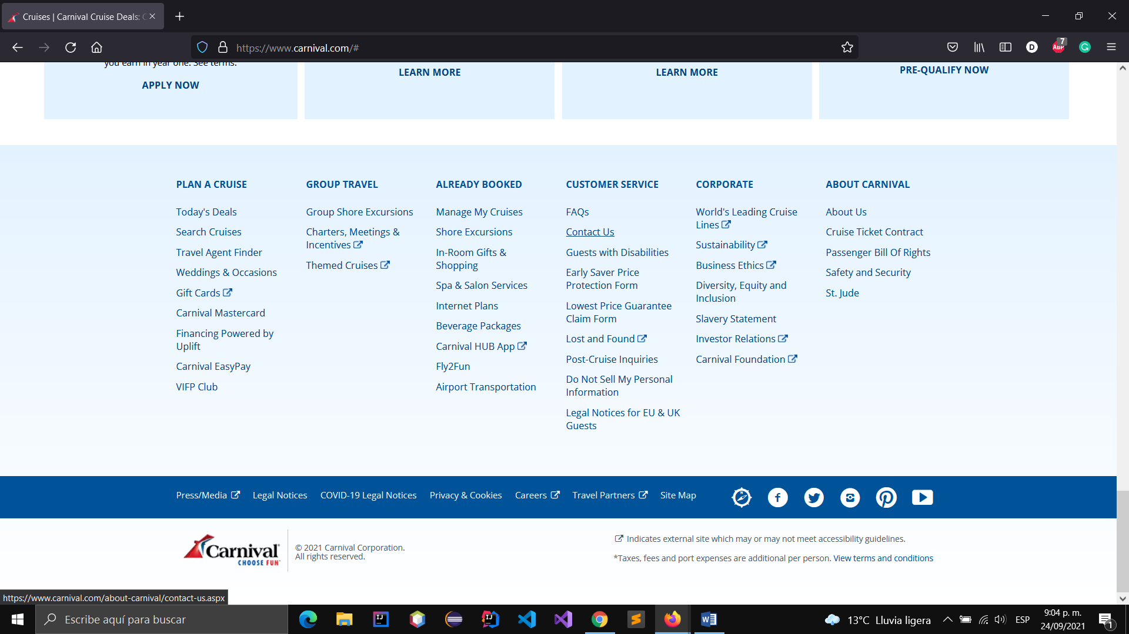

1. Click on the link

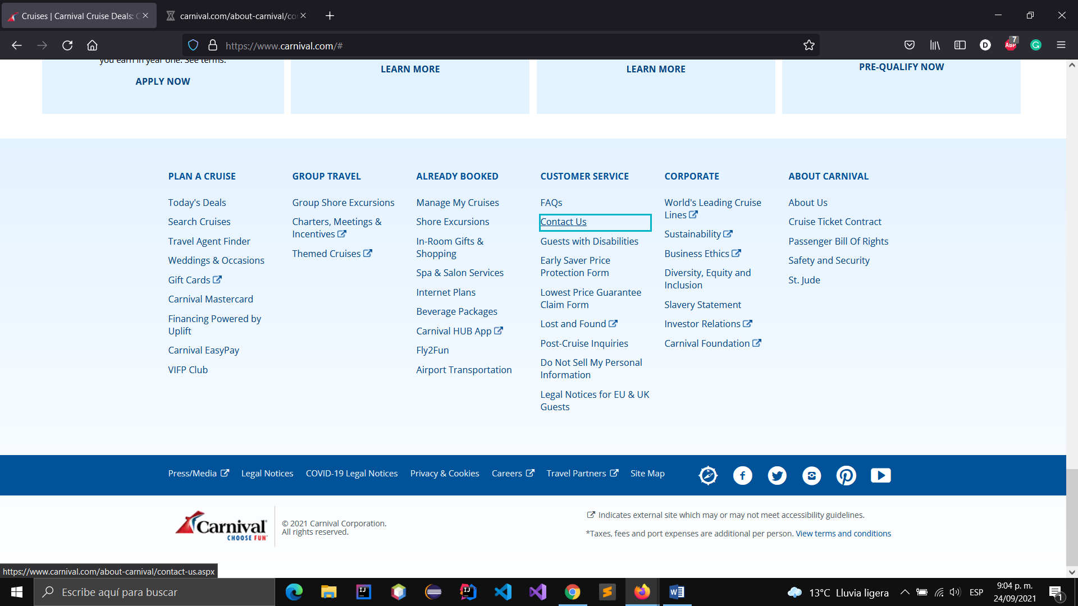

1. Verify that the link is open in a new tab.

